Threads

Name: Nayera Abd El Samie
Id: 4032

Description of the overall organization

There are more than a method to do matrix multiplication using threads we will cover two of them:

1) computation by each element
2) computation by each row

1- computation by each element:

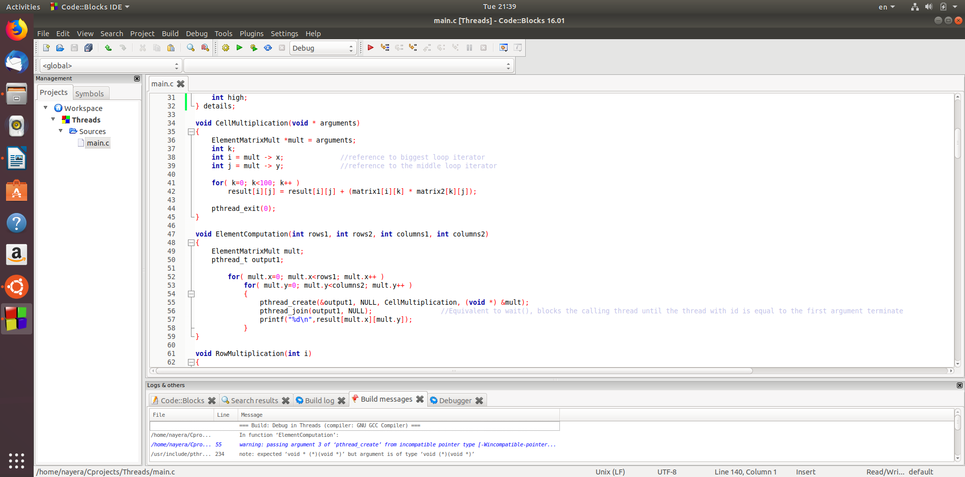
Number of threads = Number of cells

Matrix multiplication generally is done by 3 nested loops, here in our case we have number of threads equals to number of cells of the resulting matrix which is equal to number of iterations of the most inner loop so we separated this loop and let it be the called function in pthread_create function.

2- computation by each row:

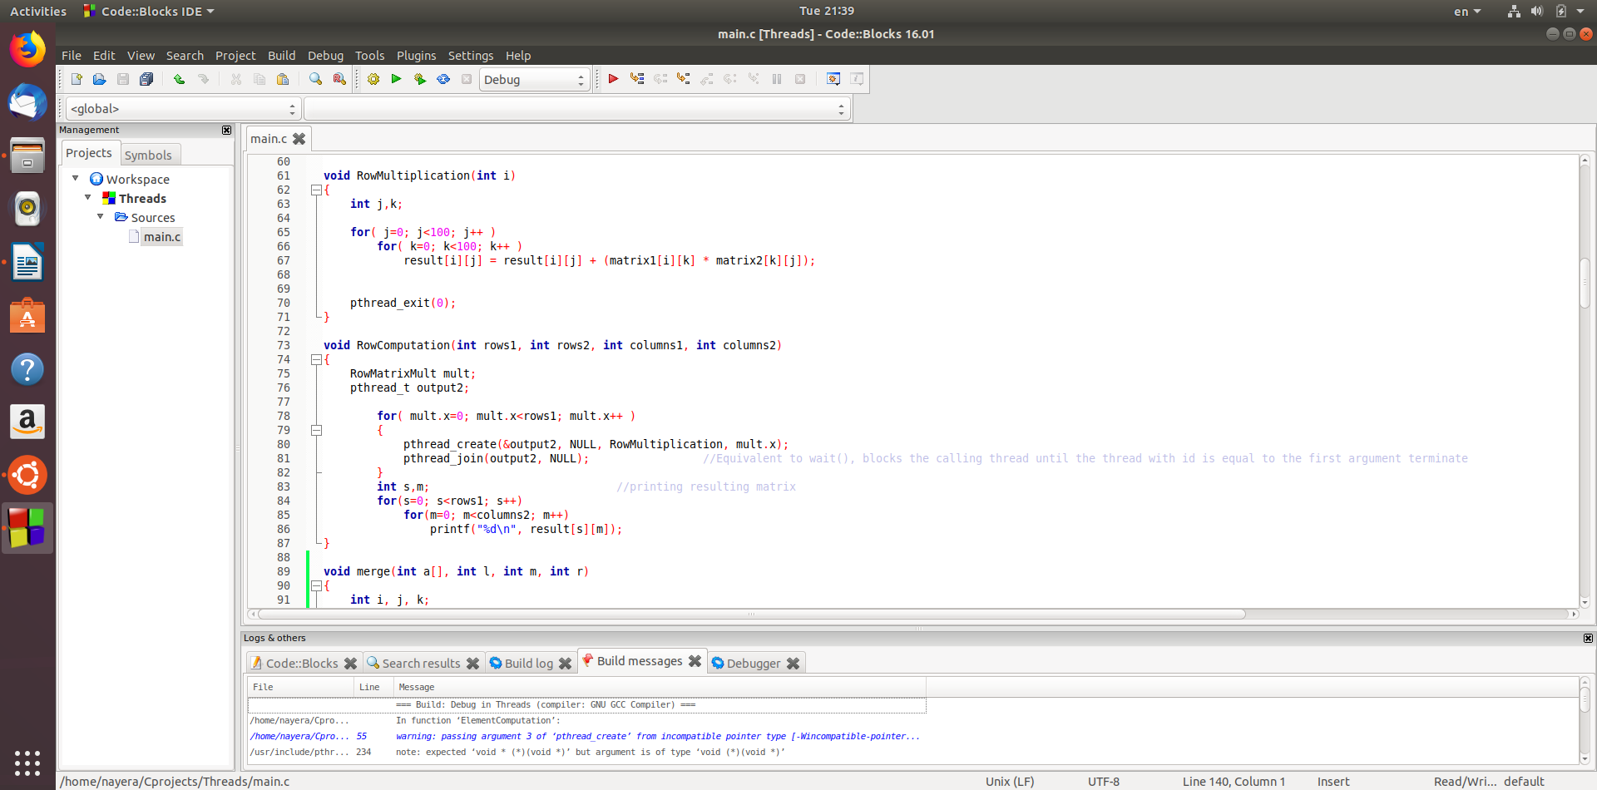
Number of threads = number of rows

In this case we separated the 2 inner loops because we want to create number of threads equals to number of rows.

Merge Sort:
doing merge sort using threads

first splitting the whole array into subarrays

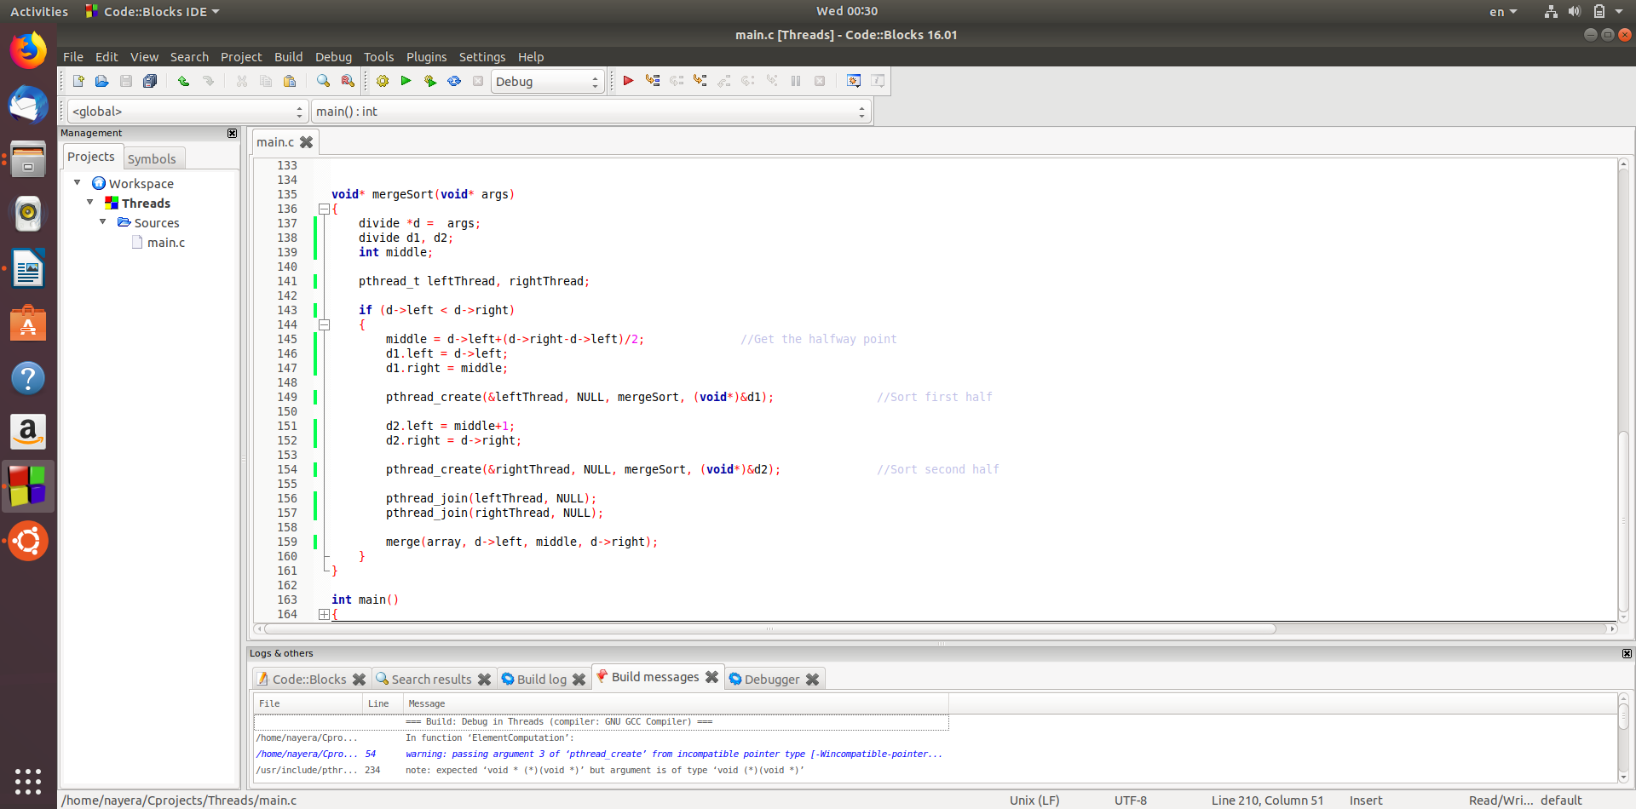
Getting the first and last elements of the given array and calculate the middle one then separate and do the same procedure to the splitted arrays until we have a thread for each element then merge the subarrays back to the main array but a sorted one.

